LIGHTHOUSE AWARD APPLICATION
Mission
Vision
To partner with forward-thinking healthcare leaders to safeguard assets, enhance patient safety, and inspire innovation.
Through our collective experience and unique expertise, we will provide the leading pathway for managing risk and improving safety in healthcare.

DEFINITION
The Lighthouse Award category focuses on patient safety, risk mitigation and management, and quality of care activities that have been completed within the past twelve (12) months.

ELIGIBILITY & STRUCTURE
- Members of AEIX are eligible to apply. For purposes of this application, “Member” includes any organization (e.g., hospital, clinic, long-term care, urgent care, behavioral health, outpatient services) as well as any department (e.g., Risk Management, Patient Safety, Quality, High Reliability Team) or individual unit (e.g., ICU, Med-Surg, Perinatal, Environmental Services, Human Resources/Talent, Education) within a member system.
- Please share this application with all clinical and operational departments within your organization that may have completed a patient safety improvement or risk reduction project and may be interested in applying for an AEIX Lighthouse Award.
- Awards are limited to projects that have been completed within the past twelve (12) months.

- Projects submitted in this category should include descriptions of how the work reduced risk or strengthened patient safety and/or quality within the organization.
  - The supporting documentation should include one or more of the following:
    - Measurable data and results
    - Stakeholder or staff feedback
    - Evidence of improved workflows, or
    - Other indicators of improvement that demonstrate changes in processes, behaviors, systems, or oversight (even if formal metrics are not available).

EXAMPLES OF PAST LIGHTHOUSE AWARD WINNERS

Decreasing Troponin Turnaround Time for Unstable Angina and Low-Risk Chest Pain Patients in the Emergency Department  Over two years, troponin turnaround time in the ED for unstable angina and low‑risk chest pain patients improved by 31 minutes, bringing median results within benchmark and substantially increasing the percentage of results completed within 60 minutes. | Decreasing Serious Safety Events  Over 18 months, the member reduced its Serious Safety Event Rate by 63.5% by strengthening safety culture and reliability practices. Key drivers included improved daily safety huddles, easier event reporting, stronger clinical leadership involvement, standardized and high‑leverage RCA processes, systemwide sharing of learning (e.g., Good Catches, HRO tools), and closed‑loop feedback—resulting in a sustained, systemwide reduction in harm.
BLS Mock Codes

The project aimed to enhance staff confidence, knowledge, and performance during the first three minutes of a Code Blue, while also monitoring the return of spontaneous circulation (ROSC) outcomes. The focus was on improving staff performance in the first three minutes of a Code Blue. The project resulted in a meaningful improvement in ROSC rates and statistically significant gains in staff confidence, particularly in CPR initiation, rhythm recognition, team communication, and defibrillator use. Debrief feedback also reflected greater comfort assuming leadership roles, activating code responses, and using the code cart.

INSTRUCTIONS

APPLICANT INSTRUCTIONS

- Complete the application in its entirety by typing into the fields. Handwritten applications will not be accepted.
- Submit your application in WORD format. Do not scan and send the document or send in a non-editable format.
- Send your completed application to your system (corporate) Risk Management Leader - or equivalent for your organization - for review and submission to AEIX.
- Before sending the application to your system (corporate) Risk Management Leader (or equivalent for your organization), applicants should collaborate with their local Risk Management and/or Patient Safety leaders in accordance with internal expectations.

RISK MANAGEMENT LEADER (CORPORATE OR SYSTEM)

- Review the application for completeness. Blank fields or incomplete information may result in disqualification.
- Submit the application(s) to AEIX at aeixawards@premierinc.com. We cannot accept applications directly from the applicant.

Application period opens Monday, May 11, 2026 and closes on Friday, July 17, 2026.

Notifications of winning and non-winning applications will be sent on or before Friday, November 20, 2026.

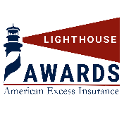



Please complete all questions and fields in the application. Incomplete applications may be disqualified.

LIGHTHOUSE AWARD APPLICATION

1 | Applicant Name(s): | Diana Mississian
2 | Title(s): | Risk Manager, Safety Database Analyst
3 | Hospital or Entity Name: | Kent Hospital
4 | Healthcare System: | Care New England
5 | Clinical or Operational Area: | Risk Management
6 | Project Title: | Building a Culture of Safety Through Standardized Event Reporting and High Reliability
7 | Mailing Address:  (where the notification of the winning applications and the award check should be sent): | Kent Hospital  Risk Management  455 Tollgate Rd.  Warwick RI 02886
8 | Telephone: | 401-736-1994
9 | E-mail Address(s): | dmississian@kentri.org
10 | Name and address of  Hospital/Entity (LOCAL) Risk Manager: | Kent Hospital  Suzanne Duni-Briggs  455 Tollgate Rd.  Warwick RI 02886
11 | Name of and address of SYSTEM Risk Manager (or equivalent role) if different from above: | Beth Fecteau  1 Blackstone Blvd  Providence, RI 02806
12 | Name and address of Hospital/Entity/System CEO | Michael Wagner  45 Willard Ave  Providence, RI 02905
13 | Name and address of Hospital/Entity/System CFO | Todd Conklin  45 Willard Ave  Providence, RI 02905

- The best practice/improvement project submitted for consideration is a: (Check all that apply)
☒ Clinical Policy, Practice, Procedure, Process, or Guideline
☒ Performance Improvement Strategy (Workflows, Culture, Oversite, etc.)
☒ Communication Strategy (Briefing before surgical procedure, senior management rounds, etc.)
☐ Other (Please specify) Click or tap here to enter text.

- Briefly describe the practice or project: (what prompted the project – the “why”, the process to complete the project – the “how”) Please limit the response to two paragraphs maximum.

Kent Hospital identified significant variation in the quality, consistency, and completeness of patient safety event reporting. Inconsistent harm classification, limited documentation, variable understanding of near misses, and differing reporting practices reduced the organization's ability to identify trends, perform meaningful investigations, and proactively mitigate risk. These inconsistencies also limited opportunities to share lessons learned and strengthen a culture of safety across departments.
To address these challenges, the Risk Management Department developed a comprehensive patient safety reporting initiative centered on High Reliability Organization (HRO) principles and standardized event reporting. The project included development of a more user friendly and standardized RLDatix reporting guidance via computer-based and in -person learning, harm classification decision-support tools & educational materials, Good Catch incentives, real-time coaching, leadership collaboration, and improved event review processes. The initiative established consistent expectations for reporting, strengthened multidisciplinary investigations, improved communication between frontline staff and leadership, and created a sustainable framework for continuous learning and organizational improvement.

- List the indicator(s) that were utilized were utilized to demonstrate success? (Please limit your response to two paragraphs). Indicators may include measurable data and results, stakeholder and/or staff feedback, evidence of improved workflows (efficiency/time, fewer errors, etc.), or other indicators of improvement that demonstrate changes in process, behaviors, systems, or oversight.

Success was demonstrated through improvements in reporting quality, staff engagement, and organizational workflow rather than a single performance metric. Following implementation, Risk Management observed more complete and consistent event documentation, improved harm classification accuracy, increased identification of near misses and Good Catch opportunities, and stronger multidisciplinary collaboration during event review and follow-up. Leaders reported greater confidence in using event data to identify trends, prioritize corrective actions, and monitor organizational risk.
Additional indicators included improved educational engagement, standardized investigative practices, enhanced communication between frontline staff and leadership, and increased use of event reporting as a learning tool rather than solely a documentation requirement. These process improvements strengthened organizational oversight and created a more reliable system for identifying patient safety risks before they resulted in patient harm.

- Please describe any other information that you feel met how this practice or project has improved patient safety, reduced risk and subsequent liability. (one paragraph maximum).
By improving the quality and consistency of patient safety reporting, Kent Hospital strengthened its ability to identify system vulnerabilities earlier, implement corrective actions more effectively, and reduce the likelihood of repeat events. Standardized reporting improved reporting events and the quality of investigations, supported more meaningful root cause analyses, enhanced leadership oversight, and reinforced a Just Culture focused on learning rather than blame. The initiative has become an integral component of Kent Hospital's patient safety program and continues to support proactive risk reduction, regulatory readiness, and continuous quality improvement.
- Are you willing to share your project with our AEIX membership? ☒ Yes ☐ No

- Was this project an original concept created by the project team? ☒ Yes ☐ No

- Or was the project based on the application (or re-application) of evidence-based best practices? ☒ Yes ☐ No While the educational materials and implementation strategy were developed locally, they are grounded in nationally recognized HRO, Just Culture, and patient safety best practices.

- How does the grant align with AEIX’s mission of “To partner with forward-thinking healthcare leaders to safeguard assets, enhance patient safety, and inspire innovation” and vision of “Through our collective experience and unique expertise, we will provide the leading pathway for managing risk and improving safety in healthcare.”?

This project embodies AEIX's mission by proactively strengthening patient safety, reducing organizational risk, and promoting innovation through standardized event reporting and High Reliability Organization principles. Rather than responding to adverse events after they occur, the initiative emphasizes early identification of hazards, consistent reporting practices, multidisciplinary learning, and continuous improvement. The project created a sustainable framework that safeguards patients, supports caregivers, enhances organizational decision-making, and can be replicated by other healthcare organizations seeking to improve safety culture and risk management.

- Additional comments:

This initiative represents more than a reporting improvement—it reflects a cultural transformation. By simplifying reporting expectations, providing practical education, encouraging Good Catch reporting, and strengthening leadership engagement, Kent Hospital has shifted event reporting from a reactive process to a proactive patient safety strategy. The project continues to evolve and serves as the foundation for future High Reliability and patient safety initiatives throughout the organization.

You may attach any supporting documentation such as graphs, tables, posters,
feedback, or PowerPoints to the application.

INSTRUCTIONS REMINDER

- Complete the application in its entirety by typing into the fields. Handwritten applications will not be accepted.
- Save the application in WORD format. Do not scan or send in a non-editable format.
- Send your application to your system (corporate) Risk Management Leader – or equivalent for your organization – for review and submission to AEIX.

Application period opens Monday, May 11, 2026 and closes on Friday, July 17, 2026.

Notifications of winning and non-winning applications will be sent on or before Friday, November 20, 2026.

Supporting Materials Attached
- Event Reporting Computer-Based Learning for all staff during onboarding, reeducated during Competency Fairs and as requested or encouraged by leadership.
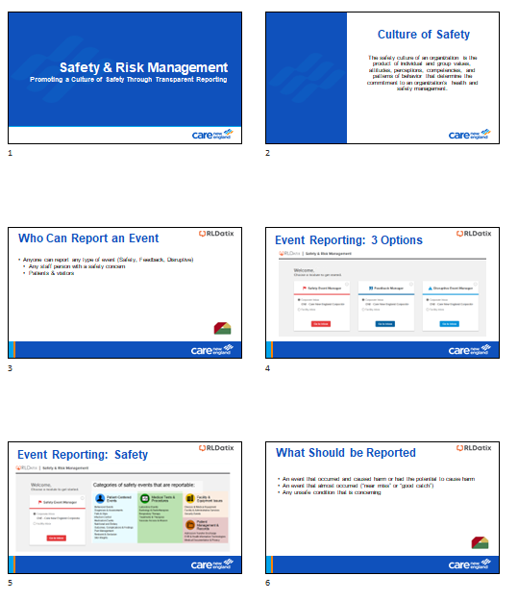

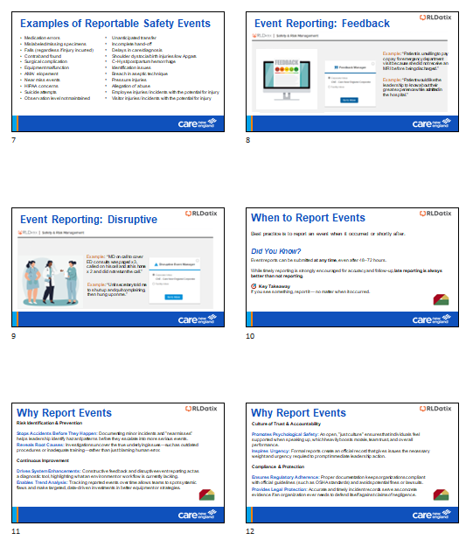
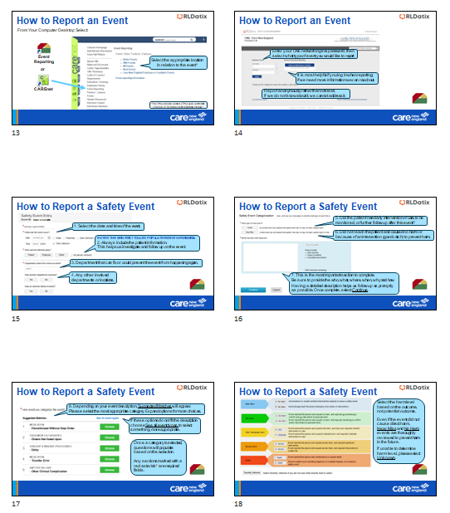
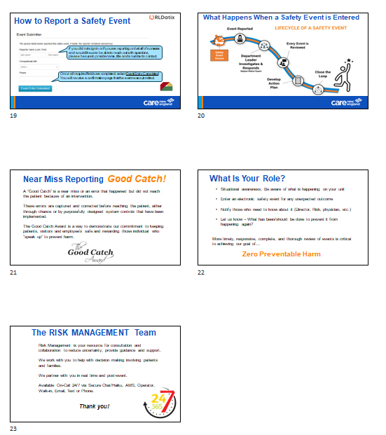

- Risk Management & Patient Safety In-Person Education – Orientation
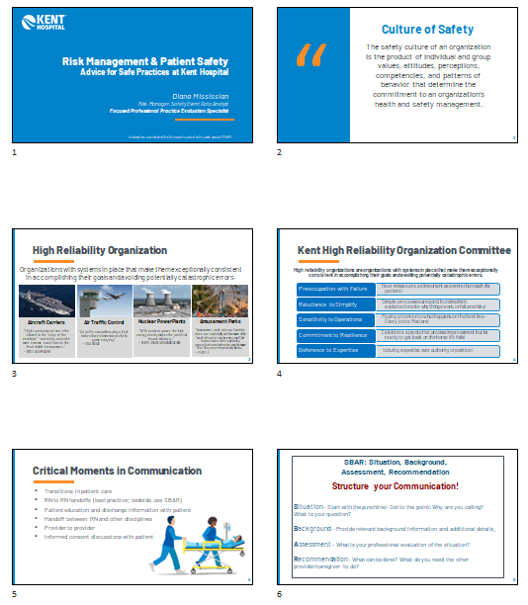
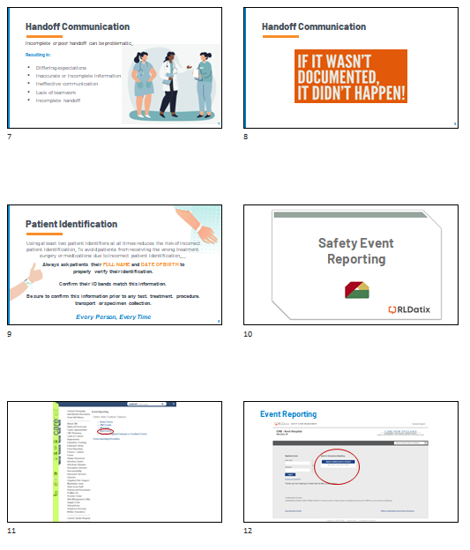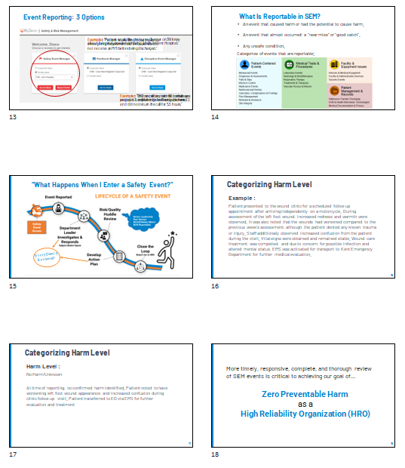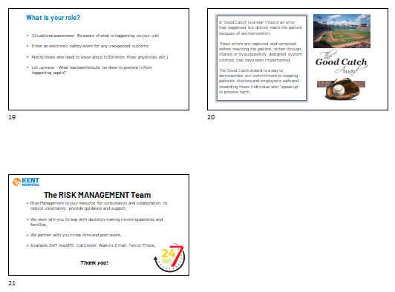

- HRO Committee Presentation In -Person monthly meeting highlighting safety data, severity scale, harm events and investigations/next steps, monthly trends and safety matrix, quarterly report outs, review of cases that required Apparent Cause Analysis (ACA) or other reviews Root Cause Analysis (RCA), Rapid Cycle Improvement (RCI) or Collaborative Case Review (CCR), Practice Alerts/Updates, and Education.
