LIGHTHOUSE AWARD APPLICATION
Mission
Vision
To partner with forward-thinking healthcare leaders to safeguard assets, enhance patient safety, and inspire innovation.
Through our collective experience and unique expertise, we will provide the leading pathway for managing risk and improving safety in healthcare.

DEFINITION
The Lighthouse Award category focuses on patient safety, risk mitigation and management, and quality of care activities that have been completed within the past twelve (12) months.

ELIGIBILITY & STRUCTURE
- Members of AEIX are eligible to apply. For purposes of this application, “Member” includes any organization (e.g., hospital, clinic, long-term care, urgent care, behavioral health, outpatient services) as well as any department (e.g., Risk Management, Patient Safety, Quality, High Reliability Team) or individual unit (e.g., ICU, Med-Surg, Perinatal, Environmental Services, Human Resources/Talent, Education) within a member system.
- Please share this application with all clinical and operational departments within your organization that may have completed a patient safety improvement or risk reduction project and may be interested in applying for an AEIX Lighthouse Award.
- Awards are limited to projects that have been completed within the past twelve (12) months.

- Projects submitted in this category should include descriptions of how the work reduced risk or strengthened patient safety and/or quality within the organization.
  - The supporting documentation should include one or more of the following:
    - Measurable data and results
    - Stakeholder or staff feedback
    - Evidence of improved workflows, or
    - Other indicators of improvement that demonstrate changes in processes, behaviors, systems, or oversight (even if formal metrics are not available).

EXAMPLES OF PAST LIGHTHOUSE AWARD WINNERS

Decreasing Troponin Turnaround Time for Unstable Angina and Low-Risk Chest Pain Patients in the Emergency Department  Over two years, troponin turnaround time in the ED for unstable angina and low‑risk chest pain patients improved by 31 minutes, bringing median results within benchmark and substantially increasing the percentage of results completed within 60 minutes. | Decreasing Serious Safety Events  Over 18 months, the member reduced its Serious Safety Event Rate by 63.5% by strengthening safety culture and reliability practices. Key drivers included improved daily safety huddles, easier event reporting, stronger clinical leadership involvement, standardized and high‑leverage RCA processes, systemwide sharing of learning (e.g., Good Catches, HRO tools), and closed‑loop feedback—resulting in a sustained, systemwide reduction in harm.
BLS Mock Codes

The project aimed to enhance staff confidence, knowledge, and performance during the first three minutes of a Code Blue, while also monitoring the return of spontaneous circulation (ROSC) outcomes. The focus was on improving staff performance in the first three minutes of a Code Blue. The project resulted in a meaningful improvement in ROSC rates and statistically significant gains in staff confidence, particularly in CPR initiation, rhythm recognition, team communication, and defibrillator use. Debrief feedback also reflected greater comfort assuming leadership roles, activating code responses, and using the code cart.

INSTRUCTIONS

APPLICANT INSTRUCTIONS

- Complete the application in its entirety by typing into the fields. Handwritten applications will not be accepted.
- Submit your application in WORD format. Do not scan and send the document or send in a non-editable format.
- Send your completed application to your system (corporate) Risk Management Leader - or equivalent for your organization - for review and submission to AEIX.
- Before sending the application to your system (corporate) Risk Management Leader (or equivalent for your organization), applicants should collaborate with their local Risk Management and/or Patient Safety leaders in accordance with internal expectations.

RISK MANAGEMENT LEADER (CORPORATE OR SYSTEM)

- Review the application for completeness. Blank fields or incomplete information may result in disqualification.
- Submit the application(s) to AEIX at aeixawards@premierinc.com. We cannot accept applications directly from the applicant.

Application period opens Monday, May 11, 2026 and closes on Friday, July 17, 2026.

Notifications of winning and non-winning applications will be sent on or before Friday, November 20, 2026.

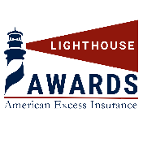



Please complete all questions and fields in the application. Incomplete applications may be disqualified.

LIGHTHOUSE AWARD APPLICATION

1 | Applicant Name(s): | Sarah Carmack, Karen Wheat, Elizabeth Ritter, Julie Collins, and Lauren Goodpaster.
2 | Title(s): | Clinical Quality Resources Manager, Clinical Quality Consultant, System Manager Clinical Documentation, Director Utilization Management, Manager Medical Records.
3 | Hospital or Entity Name: | TriHealth
4 | Healthcare System: | TriHealth
5 | Clinical or Operational Area: | Clinical Documentation and Coding
6 | Project Title: | Capturing True Clinical Complexity to Drive Mortality Index Reduction
7 | Mailing Address:  (where the notification of the winning applications and the award check should be sent): | TriHealth Baldwin  625 Eden Park Drive  Cincinnati, OH 45202
8 | Telephone: | 317-840-6888
9 | E-mail Address(s): | Jennifer_rainer@trihealth.com
10 | Name and address of  Hospital/Entity (LOCAL) Risk Manager: | Monica McPeek, TriHealth  625 Eden Park Drive, Cincinnati OH 45202
11 | Name of and address of SYSTEM Risk Manager (or equivalent role) if different from above:
12 | Name and address of Hospital/Entity/System CEO | Terri Hanlon-Bremer  625 Eden Park Drive  Cincinnati, OH 45202
13 | Name and address of Hospital/Entity/System CFO | Todd Anderson  625 Eden Park Drive  Cincinnati, OH 45202

- The best practice/improvement project submitted for consideration is a: (Check all that apply)
☒ Clinical Policy, Practice, Procedure, Process, or Guideline
☒ Performance Improvement Strategy (Workflows, Culture, Oversite, etc.)
☐ Communication Strategy (Briefing before surgical procedure, senior management rounds, etc.)
☐ Other (Please specify) Click or tap here to enter text.

- Briefly describe the practice or project: (what prompted the project – the “why”, the process to complete the project – the “how”) Please limit the response to two paragraphs maximum.

TriHealth launched a mortality index improvement initiative to ensure that the complexity of care provided to our patients is accurately reflected in the medical record and subsequent coded data. Our data showed that while our mortality index remained well above 1.0, we consistently had less observed deaths when compared to similar hospitals, but lower expected mortality rates. This indicated that we were not accurately reflecting the severity of the acuity of our patients consistently. Patients with significant comorbidities, organ dysfunction, end-of-life care decisions, and other clinically relevant conditions were often receiving appropriate interventions that were not consistently captured in a way that reflected their true severity of illness and their overall risk of mortality. As a result, observed-to-expected mortality measures could underestimate the complexity of care being delivered. Improving documentation and coding accuracy became essential not only for performance metrics such as the mortality index, but also for demonstrating the exceptional care provided across the organization and supporting meaningful quality improvement efforts.

To address this opportunity, TriHealth's Clinical Documentation Integrity (CDI) and Health Information Management (HIM) team resources partnered with physician leaders and the quality team to implement a comprehensive mortality improvement initiative. The initiative expanded beyond traditional DRG-focused documentation review to emphasize the capture of all clinically significant conditions, interventions, and care decisions that influence risk adjustment and expected mortality calculations, regardless of their impact on reimbursement. The team conducted targeted mortality reviews, identified opportunities for enhanced documentation of severity of illness and extended variables, provided physician education, and implemented concurrent query processes to support accurate clinical representation. This multidisciplinary approach enabled TriHealth to more accurately reflect patient acuity, support mortality index improvement goals, and establish a sustainable process for ongoing performance excellence.

- List the indicator(s) that were utilized were utilized to demonstrate success? (Please limit your response to two paragraphs). Indicators may include measurable data and results, stakeholder and/or staff feedback, evidence of improved workflows (efficiency/time, fewer errors, etc.), or other indicators of improvement that demonstrate changes in process, behaviors, systems, or oversight.

To validate success, the team tracked the observed to expected mortality index. Since the initiative began, TriHealth has seen a sharp decline in mortality index. The mean mortality index for Bethesda North and Good Samaritan Hospital was 1.17 and 1.06 respectfully from Jan to Oct of 2025. Once the team began case reviews and recommendations, the index has fallen to mean of .95 and .77 from November 2025 to May 2026. Graphs included below.

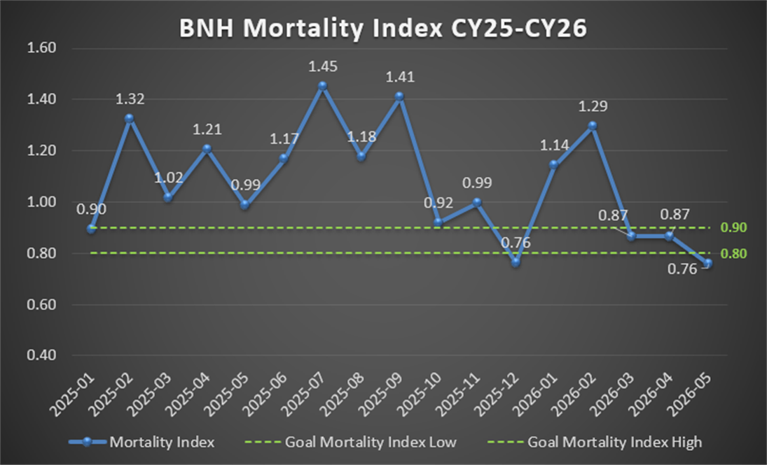

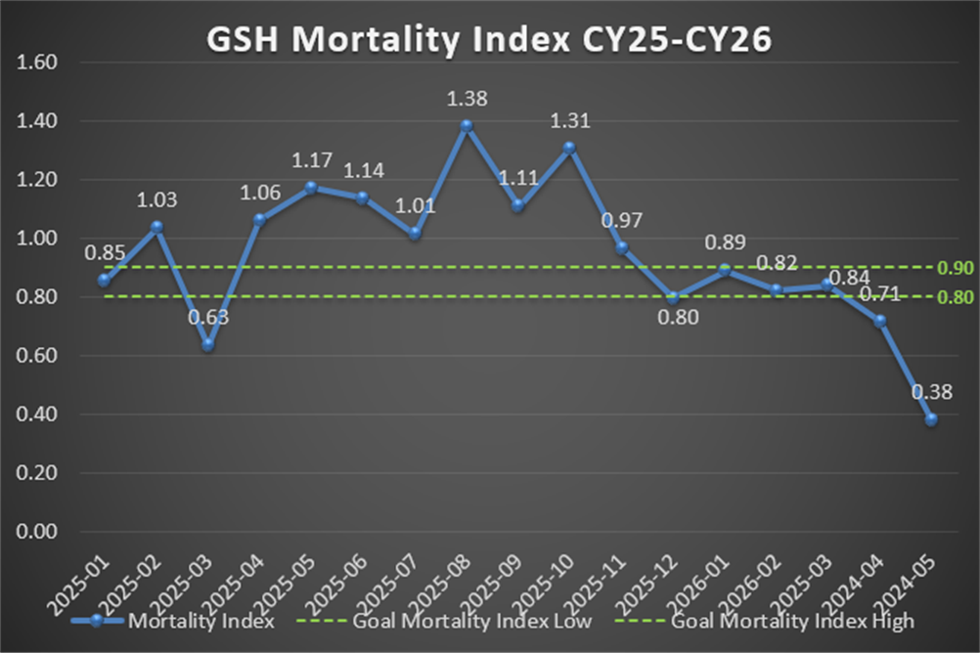

- Please describe any other information that you feel met how this practice or project has improved patient safety, reduced risk and subsequent liability. (one paragraph maximum).

By improving the accuracy and completeness of clinical documentation, this initiative strengthened patient safety and reduced organizational risk by ensuring that the medical record clearly reflected each patient's true severity of illness, comorbid conditions, and the clinical interventions provided throughout the hospitalization. The collaborative efforts of the CDI team, HIM team, physicians, and quality team enhanced communication across the continuum of care, supported more informed clinical decision-making, and improved the reliability of data used to identify mortality trends and quality improvement opportunities. Accurate capture of risk-adjusting variables and care complexity also reduced the potential for misinterpretation of outcomes, supported regulatory and accreditation reporting, and provided a more defensible representation of the care delivered. By establishing sustainable processes for concurrent review, provider education, and documentation improvement, the initiative promoted a culture of clinical excellence, transparency, and continuous learning while helping ensure that quality and safety performance metrics accurately reflected the exceptional care provided to TriHealth patients.

- Are you willing to share your project with our AEIX membership? ☒ Yes ☐ No

- Was this project an original concept created by the project team? ☒ Yes ☐ No

- Or was the project based on the application (or re-application) of evidence-based best practices?
☒ Yes ☐ No

- How does the grant align with AEIX’s mission of “To partner with forward-thinking healthcare leaders to safeguard assets, enhance patient safety, and inspire innovation” and vision of “Through our collective experience and unique expertise, we will provide the leading pathway for managing risk and improving safety in healthcare.”?

This initiative aligns with AEIX’s mission to partner with forward-thinking healthcare leaders to safeguard assets, enhance patient safety, and inspire innovation by addressing the often-overlooked connection between clinical documentation quality, patient safety outcomes, and organizational risk. This work enhanced the reliability of mortality data, strengthened the organization's ability to identify safety improvement opportunities, and reduced the risk associated with incomplete or inaccurate reporting of clinical outcomes. The initiative also reflects AEIX’s vision of providing a leading pathway for managing risk and improving safety in healthcare by leveraging multidisciplinary expertise, data-driven decision-making, and sustainable documentation practices to improve outcome measurement, support transparency, and foster a culture of continuous improvement. By ensuring that quality metrics accurately reflect the care delivered, the project advances safer patient care while creating a more resilient and accountable healthcare system.

- Additional comments:

Click or tap here to enter text.

You may attach any supporting documentation such as graphs, tables, posters,
feedback, or PowerPoints to the application.

INSTRUCTIONS REMINDER

- Complete the application in its entirety by typing into the fields. Handwritten applications will not be accepted.
- Save the application in WORD format. Do not scan or send in a non-editable format.
- Send your application to your system (corporate) Risk Management Leader – or equivalent for your organization – for review and submission to AEIX.

Application period opens Monday, May 11, 2026 and closes on Friday, July 17, 2026.

Notifications of winning and non-winning applications will be sent on or before Friday, November 20, 2026.

