**AWARD APPLICATION**

**DEFINITION:**

The Lighthouse Award category focuses on quality and patient safety risk mitigation activities that have already been *completed*, with accompanying data to demonstrate the project's impact.

**ELIGIBILITY:**

Members of AEIX. “Member” includes any organization (hospital, clinic, long term care, urgent care, behavioral health, outpatient services, etc.) and department (Risk Management, Patient Safety, Quality, High Reliability Team, or an individual unit such as an ICU, Med-Surg, Peri-natal, Environmental Services, Human Resources/Talent, Education department, etc.) within the member system.

**Please share this application with all the clinical and operational departments within your organization** that may have completed a risk reduction or quality improvement project who may be interested in applying for an AEI Risk Management Award.

* Awards are limited to projects that have been completed within the past twelve (12) months.
* Awards must have accompanying data that validate the project was successful in demonstrating improvement (risk reduction/quality improvement).

**INSTRUCTIONS:**

1. Complete the application in its entirety.

* In the event of missing or incomplete information, *if* the timeline allows, AEIX will send applications back to the member and request completion and/or clarification of the application.
* Blanks and/or incomplete information may result in disqualification if the deadline for application submission has passed.

1. Applications must be submitted to AEIX in **WORD** format.

* Applications must be completed electronically (typed) and be sent in an editable format (do not scan and send the document or send in a non-editable format such as a pdf).

1. Completed applications should be sent via email, as a WORD document attachment,  with a copy to the organization’s risk management leader, to the following email: [aeixawards@premierinc.com](mailto:aeixawards@premierinc.com).
2. Please note, award monies are not intended to be used for reimbursing hospital staff or the project participants to compensate them financially for their efforts.

**DEADLINE FOR AWARD APPLICATIONS IS FRIDAY JULY 18th, 2025**

**AEIX Lighthouse AWARD Application**

**ALL fields/questions within the application must be completed prior to the submission.**

|  |  |  |
| --- | --- | --- |
| 1 | Applicant Name(s): | Laura Sherman/Jenn Rainer |
| 2 | Title/Role at organization: | Director of Patient Safety/VP Safety and Quality |
| 3 | Hospital or Entity Name: | TriHealth |
| 4 | Healthcare System: | TriHealth of OH |
| 5 | Clinical or Operational Area:  (Risk, Patient Safety, Quality, Perinatal, OR, Med-Surg, etc.) | Patient Safety |
| 6 | Project Title: | Decreasing Serious Safety Events |
| 7 | Mailing Address: | 625 Eden Park Drive, Cincinnati OH 45202 |
| 8 | Telephone: | 513.569.9338 |
| 9 | E-mail Address: | Jennifer_rainer@trihealth.com |

|  |  |  |
| --- | --- | --- |
| 10 | Name and address of  Hospital/Entity (local) Risk Manager: | Monica McPeek, TriHealth  625 Eden Park Drive, Cincinnati OH 45202 |
| 11 | Name of and address of SYSTEM Risk  Manager if different from above: | Click or tap here to enter text. |
| 12 | Name and address of  Hospital/Entity/System CEO | Mark Clement  625 Eden Park Drive, Cincinnati OH 45202 |
| 13 | Name and address of  Hospital/Entity/System CFO | Todd Anderson  625 Eden Park Drive, Cincinnati OH 45202 |

1. **The best practice/improvement project submitted for consideration is a:** *(Check all that apply)*

**Clinical Policy**

**Performance Improvement Strategy** *(Six Sigma, etc.)*

**Communication Strategy** *(Briefing before surgical procedure, senior management rounds, etc.)*

**Other** *(Please specify)*

Click or tap here to enter text.

1. **Briefly describe the practice or project:** *(what prompted the project – the why, the process to complete the project – the how)* ***Please limit the response to two paragraphs maximum.***

In an 18-month period, TriHealth decreased its Serious Safety Event Rate (SSER) by 63.5%. In September of 2023, the organizational SSER was 2.06/10,000 adjusted patient days, and by March 2025, we decreased that 12-month rolling indicator to 0.75/10,000 adjusted patient days. The following strategies were implemented in that time period: 1) Site-specific Daily Safety Huddle structure was enhanced to strengthen report-out and informational sharing for situational awareness, 2) The event reporting system was streamlined to encourage reporting, 3) The existing event classification team was restructured to include chief nurse participation to ensure diverse viewpoints were always considered, 4) Individual and System Failure Modes were added to event classification to provide insight and guidance with gaps in High Reliability (HRO) Practices, 5) HRO tool of the month was implemented and shared throughout the organization to decrease safety events, 6)The Safety and Quality Newsletter was enhanced, sharing Good Catches and other safety tips across the health system on a monthly basis, 7) An algorithm was implemented to ensure RCA corrective actions were spread across the system for serious safety event prevention, 8) Steps were taken to ensure closed loop feedback to team members sharing safety events or concerns, and 9) Standardized the RCA process/tools to ensure high leverage corrective actions to prevent recurrence.

1. **List the metric(s) have been used to measure and to sustain success?** *(one paragraph maximum plus*

*before and after data)*

As per above, the Serious Safety Event Rate decreased 63.5% in an 18-month period with targeted interventions designed to enhance safety and shared learnings.

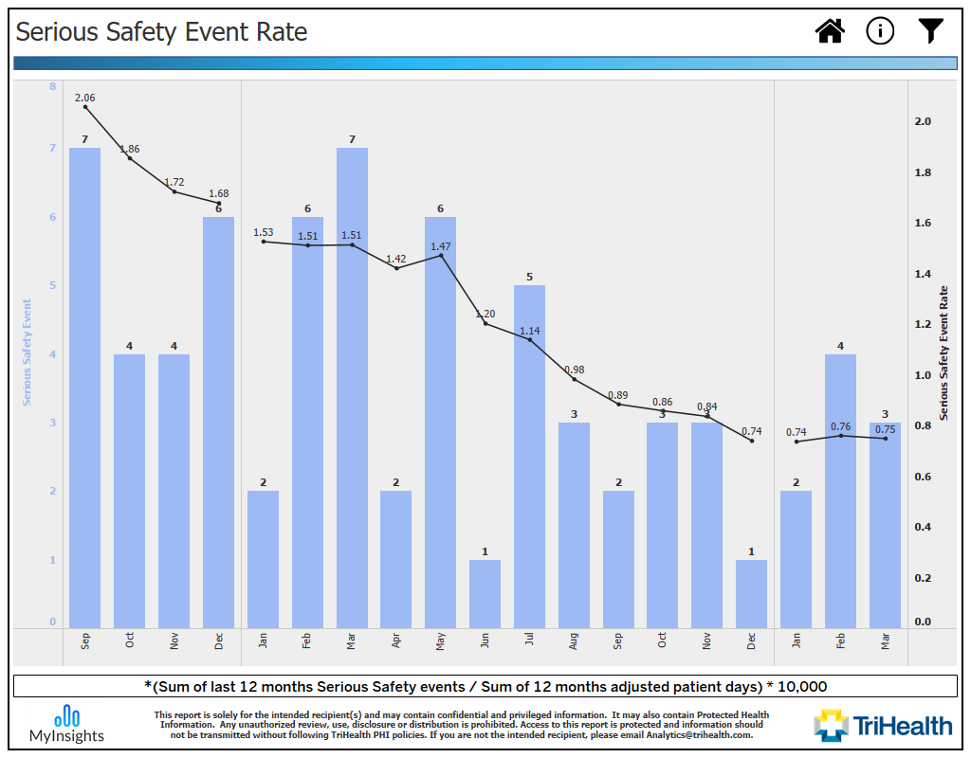

1. **Briefly describe how this practice or project has improved patient safety, reduced risk and subsequent**

**liability)** *(****one paragraph maximum****).*

Decreasing the SSER has improved safety through less adverse preventable patient safety events, it has strengthened our culture of safety, and it has clearly decreased liability to the organization because we have less events with a probability of litigation**.**

***You may attach any supporting documentation such as graphs, tables, posters, PowerPoint to the application.***

1. **Are you willing to allow other AEIX members to have access to your application and data upon request?**

**Yes**

**No**

1. **Was this project an *original concept* created by the project team?  Yes  No**

**Additional notes/explanation *if needed*:**  We consistently utilize the HPI/Press Ganey patient safety methodology.

1. ***Or* was the project based on evidence-based best practices being applied (or reapplied with improvement strategies) at your healthcare system for the first time?  Yes  No**

**Additional notes/explanation if needed:**  As per above.

1. **How does the Project align with AEIX’s mission of “To partner with forward-thinking healthcare leaders to safeguard assets, enhance patient safety, and inspire innovation” and vision of “Through our collective experience and unique expertise, we will provide the leading pathway for managing risk and improving safety in healthcare.”?**

We believe strongly in our mission to improve the health status of the people we serve, and that requires that we prevent avoidable harm. We continue to monitor best practices in patient safety and adjust our practices to reflect those. We are steadfast in our application and analysis of our safety culture surveys, and consistently hold an annual Safety Summit for our leaders and providers.

1. **Additional comments:**

Click or tap here to enter text.

***You may attach any supporting documentation such as graphs, tables, posters, PowerPoint to the application.***

**DEADLINE FOR AWARD APPLICATIONS IS FRIDAY JULY 18th, 2025**

*It is recommended that applications are submitted well in advance of the deadline as in the event of missing or incomplete information, if the timeline allows, AEIX will send applications back to the member and request completion and/or clarification of the application.*

*Please complete the application thoroughly as blanks and/or incomplete information may result in disqualification.*

**The following questions (I. A through D, and II) must be completed by the applicant *or* by a Risk Management or Patient Safety Leader:**

1. **Using the following criteria, applications will be evaluated and scored on a scale of 1-3, with three (3) being highest:**
   1. **Potential to improve safety and reduce liability:**

Practice appears to have had *little* effect on improving safety and reducing liability. (1)

Practice appears to have had *some* effect on improving safety and reduced liability, but metrics are

not distinctly defined and/or it is unclear that measurable effect can be sustained. (2)

Practice appears to have had a *strong* effect on improving safety and reducing liability with clearly

defined metrics and sustainability. (3)

* 1. **Potential to share best practice among AEIX members:**

*Little* potential for sharing with or translation of best practices to other organizations (e.g.,

implementation requires major budgetary commitment; topic is highly specialized and/or metrics are

not clearly defined). (1)

*Some* potential for sharing or translation of best practices to other organizations; however, the

implementation process may pose challenges *due to f*actors such as significant budgetary

commitments or the specialized nature of the topic.

* While certain practice settings, such as behavioral health, may find the application relevant, the overall applicability may be limited. Additionally, the metrics for evaluation are not clearly defined.

*Strong* potential for sharing with and translation of best practices to other member organizations. (3)

* 1. **Potential to impact severity of risk exposure:**

Appears to have potential for addressing an issue which may be important from other perspectives,

such as patient satisfaction or reporting of data, but it is *unlikely to impact severity of risk in the clinical*

*or safety area*.(1)

Appears to have potential for addressing an issue which may not result in catastrophic loss, but which

is nevertheless significant regarding patient safety or clinical outcomes (e.g., preventing burns from

hot liquids on dietary trays). (2)

Appears to have potential for addressing an issue which clearly affects severe malpractice exposure

caused by significant risk events (e.g., birth injury). (3)

* 1. **Innovation level of the Project:**

Project/practice is new to this organization but is based primarily on best practices firmly established

in the industry. (1)

Project/practice was developed primarily by applicants with some assistance from outside entities,

and/or it contains well-established best practices but includes additional innovative features which

may benefit other organizations. (2)

Project/practice was created primarily (or solely) by applicants and could add to established literature

or industry best practices. (3)

* 1. **Alignment with AEIX’s mission “*To partner with forward-thinking healthcare leaders to safeguard assets, enhance patient safety, and inspire innovation” and vision of “Through our collective experience and unique expertise, we will provide the leading pathway for managing risk and improving safety in healthcare.*”:**

Project appears to minimally or no alignment with the AEIX mission. (1)

Project appears to have some alignment with the AEIX mission. (2)

Project clearly aligns with the AEIX mission. (3)

1. **Applicant or Risk/Patient Safety Comments:**

Click or tap here to enter text.

**III.** **ATTESTATION:**

**Yes, I (the applicant), attest to the notification of my organization’s Risk Management Leadership of this application and its content,**

**Completed applications should be sent via email, as a WORD document attachment,  with a copy to the**

**organization’s risk management leader, to the following email:** [**aeixawards@premierinc.com**](mailto:aeixawards@premierinc.com)**.**

**DEADLINE FOR AWARD APPLICATIONS IS FRIDAY JULY 18th, 2025**

*It is recommended that applications are submitted well in advance of the deadline as in the event of missing or incomplete information, if the timeline allows, AEIX will send applications back to the member and request completion and/or clarification of the application.*

*Blanks and/or incomplete information may result in disqualification if the deadline for application submission has passed.*

**TIMELINE**

* **5/12/2025** - Application period opens
* **7/18/2025** - Application period closes
* **8/19/2025** - Awards & Grants Subcommittee meeting (review applications and vote on winners)
* **9/16/2025** - Subcommittee recommendations to IAC the slate of winners for approval
* **11/11/2025 – SAC/Board Meeting – final approval of winners**

*Notification of winners/non-winners via U.S. Mail occurs following the SAC meeting.*