POWER BI DASHBOARD METRICS
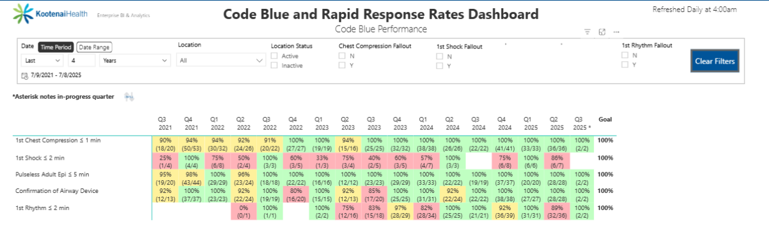
*** BLS Mock codes were implemented in medical surgical units and the progressive care unit end of Q2 2024 with marked improvement in the next two quarters. Q4 2024 data showed variance in the 1st shock ≤ 2 min in critical care and therefore the activity was extended into the critical care departments.

