**AWARD APPLICATION**

**DEFINITION:**

The Lighthouse Award category focuses on quality and patient safety risk mitigation activities that have already been *completed*, with accompanying data to demonstrate the project's impact.

**ELIGIBILITY:**

Members of AEIX. “Member” includes any organization (hospital, clinic, long term care, urgent care, behavioral health, outpatient services, etc.) and department (Risk Management, Patient Safety, Quality, High Reliability Team, or an individual unit such as an ICU, Med-Surg, Peri-natal, Environmental Services, Human Resources/Talent, Education department, etc.) within the member system.

**Please share this application with all the clinical and operational departments within your organization** that may have completed a risk reduction or quality improvement project who may be interested in applying for an AEI Risk Management Award.

* Awards are limited to projects that have been completed within the past twelve (12) months.
* Awards must have accompanying data that validate the project was successful in demonstrating improvement (risk reduction/quality improvement).

**INSTRUCTIONS:**

1. Complete the application in its entirety.

* In the event of missing or incomplete information, *if* the timeline allows, AEIX will send applications back to the member and request completion and/or clarification of the application.
* Blanks and/or incomplete information may result in disqualification if the deadline for application submission has passed.

1. Applications must be submitted to AEIX in **WORD** format.

* Applications must be completed electronically (typed) and be sent in an editable format (do not scan and send the document or send in a non-editable format such as a pdf).

1. Completed applications should be sent via email, as a WORD document attachment,  with a copy to the organization’s risk management leader, to the following email: [aeixawards@premierinc.com](mailto:aeixawards@premierinc.com).
2. Please note, award monies are not intended to be used for reimbursing hospital staff or the project participants to compensate them financially for their efforts.

**DEADLINE FOR AWARD APPLICATIONS IS FRIDAY JULY 18th, 2025**

**AEIX Lighthouse AWARD Application**

**ALL fields/questions within the application must be completed prior to the submission.**

|  |  |  |
| --- | --- | --- |
| 1 | Applicant Name(s): | Kat Remner, Benjamin Hiett |
| K | Title/Role at organization: | Mgr Workforce Health, Wellness & Safety |
| 3 | Hospital or Entity Name: | Valley Children’s Hospital |
| 4 | Healthcare System: | Pediatric Hospital |
| 5 | Clinical or Operational Area:  (Risk, Patient Safety, Quality, Perinatal, OR, Med-Surg, etc.) | Risk Management and Safety |
| 6 | Project Title: | Handy Cone™: Caution Signs |
| 7 | Mailing Address: | 9300 Valley Children's Place Madera, CA 93636-8762 |
| 8 | Telephone: | 559-353-8673 |
| 9 | E-mail Address: | [KRemner@valleychildrens.org](mailto:KRemner@valleychildrens.org) / [BHiett@valleychildrens.org](mailto:BHiett@valleychildrens.org) |

|  |  |  |
| --- | --- | --- |
| 10 | Name and address of  Hospital/Entity (local) Risk Manager: | Valley Children’s Hospital  9300 Valley Children's Place Madera, CA 93636-8762 |
| 11 | Name of and address of SYSTEM Risk  Manager if different from above: | Nathan Powell VP and Chief Risk Officer |
| 12 | Name and address of  Hospital/Entity/System CEO | Todd Suntrapak: President & CEO |
| 13 | Name and address of  Hospital/Entity/System CFO | Tina Mycroft: SVP & Chief Financial Officer |

1. **The best practice/improvement project submitted for consideration is a:** *(Check all that apply)*

**Clinical Policy**

**Performance Improvement Strategy** *(Six Sigma, etc.)*

**Communication Strategy** *(Briefing before surgical procedure, senior management rounds, etc.)*

**Other** *(Please specify)*

The hospital is enhancing safety by installing wall-mounted "Handy Cone™ Wet Floor" signs in key areas, making it easy for anyone—staff, visitors, patients, or contractors—to respond quickly to spills. Each station includes direct contact info for the Environmental Services (EVS) department, ensuring rapid reporting and cleanup.

1. **Briefly describe the practice or project:** *(what prompted the project – the why, the process to complete the project – the how)* ***Please limit the response to two paragraphs maximum.***

This project was launched to proactively reduce the hospital's liability by minimizing slip, trip, and fall incidents involving patients, visitors, and staff—ultimately safeguarding both its financial stability and reputation. Wet floor signs have been strategically installed in high-traffic areas where spills are most likely to occur—such as the cafeteria, Starbucks, water fountains, elevators, and the gift shop. In the event of a spill, anyone nearby can promptly remove a sign from the wall-mounted holster and position it near the affected area. Each station provides direct contact information for the Environmental Services (EVS) department, enabling swift notification and immediate dispatch to manage and eliminate the hazard.

1. **List the metric(s) have been used to measure and to sustain success?** *(one paragraph maximum plus*

*before and after data)*

The hospital closely monitors incident data reported by staff, patients, and visitors to identify high-risk areas where safety tools are most needed. This information guides the strategic placement of wet floor signage and other hazard-mitigation resources. Data is tracked and reviewed monthly to assess trends and to make informed improvements. Please refer to the graph below for a visual representation of incidents using the most recent data from the start of fiscal year 2023 through June 2025.

The initial phase of the Handy Cone™ Wet Floor Sign initiative was implemented around the end of April in 2024, resulting in a measurable reduction of 29.17% in reported staff slip, trip, and fall incidents and a reduction of 25% in visitor slip, trip, and fall incidents. Prior to the launch, the hospital averaged 3.43 cases per month for staff and 2 cases per month for visitors. The frequency of both cases dropped to 2.43 cases for staff and 1.5 cases for visitors following the introduction of the signage. The first set of signs was placed in high-traffic areas on the ground floor. The initiative was completed in February 2025, with the installation of 15 additional units across targeted locations on the first and second floors—further extending the reach of the safety program and strengthening hospital-wide hazard mitigation. Additionally, education on how to use the instrument was created and published to the staff.

1. **Briefly describe how this practice or project has improved patient safety, reduced risk and subsequent**

**liability)** *(****one paragraph maximum****).*

The Handy Cone™: Caution Sign initiative has significantly enhanced safety by creating an environment where wet floor hazards can be addressed immediately by anyone nearby. By positioning the necessary signage materials within arm’s reach in high-risk areas, the time and effort previously required to locate a wet floor sign has been virtually eliminated. This not only alerts passersby to potential slip hazards, but also provides clear contact information for key Environmental Services (EVS) personnel—ensuring quick notification and prompt cleanup response.

***You may attach any supporting documentation such as graphs, tables, posters, PowerPoint to the application.***

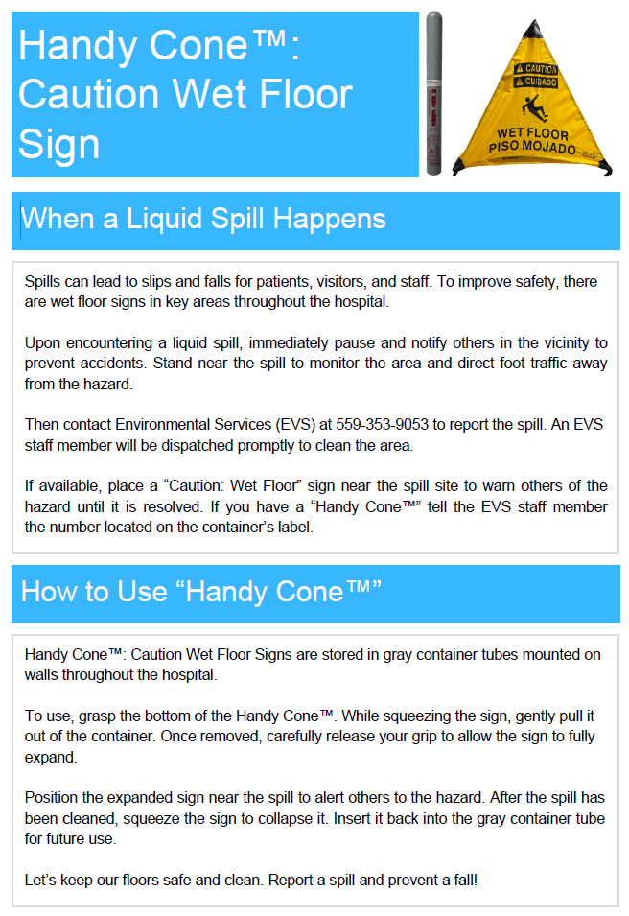

1. **Are you willing to allow other AEIX members to have access to your application and data upon request?**

**Yes**

**No**

1. **Was this project an *original concept* created by the project team?  Yes  No**

**Additional notes/explanation *if needed*:** We’ve extended this initiative hospital-wide and are actively exploring the acquisition of additional units to further expand coverage and enhance hazard mitigation efforts.

1. ***Or* was the project based on evidence-based best practices being applied (or reapplied with improvement strategies) at your healthcare system for the first time?  Yes  No**

**Additional notes/explanation if needed:** During the development of this process, we engaged key stakeholders—hospital staff—to identify the most suitable locations within their work areas for installing the wet floor signs.

1. **How does the Project align with AEIX’s mission of “To partner with forward-thinking healthcare leaders to safeguard assets, enhance patient safety, and inspire innovation” and vision of “Through our collective experience and unique expertise, we will provide the leading pathway for managing risk and improving safety in healthcare.”?**

Guided by the hospital’s motto, “Futures Worth Fighting For,” this initiative reinforces our commitment to safety and healing. By equipping patients, visitors, and staff with easily accessible wet floor signage, we empower everyone to play a role in preventing slip, trip, and fall incidents. Through our collective efforts, we not only protect the hospital from liability but also inspire other facilities to adopt similar practices—as we strive toward a world where hospitals truly serve as places of healing, free from avoidable harm when our community turns to us in their time of need.

1. **Additional comments:**

Click or tap here to enter text.

***You may attach any supporting documentation such as graphs, tables, posters, PowerPoint to the application.***

**DEADLINE FOR AWARD APPLICATIONS IS FRIDAY JULY 18th, 2025**

*It is recommended that applications are submitted well in advance of the deadline as in the event of missing or incomplete information, if the timeline allows, AEIX will send applications back to the member and request completion and/or clarification of the application.*

*Please complete the application thoroughly as blanks and/or incomplete information may result in disqualification.*

**The following questions (I. A through D, and II) must be completed by the applicant *or* by a Risk Management or Patient Safety Leader:**

1. **Using the following criteria, applications will be evaluated and scored on a scale of 1-3, with three (3) being highest:**
   1. **Potential to improve safety and reduce liability:**

Practice appears to have had *little* effect on improving safety and reducing liability. (1)

Practice appears to have had *some* effect on improving safety and reduced liability, but metrics are

not distinctly defined and/or it is unclear that measurable effect can be sustained. (2)

Practice appears to have had a *strong* effect on improving safety and reducing liability with clearly

defined metrics and sustainability. (3)

* 1. **Potential to share best practice among AEIX members:**

*Little* potential for sharing with or translation of best practices to other organizations (e.g.,

implementation requires major budgetary commitment; topic is highly specialized and/or metrics are

not clearly defined). (1)

*Some* potential for sharing or translation of best practices to other organizations; however, the

implementation process may pose challenges *due to f*actors such as significant budgetary

commitments or the specialized nature of the topic.

* While certain practice settings, such as behavioral health, may find the application relevant, the overall applicability may be limited. Additionally, the metrics for evaluation are not clearly defined.

*Strong* potential for sharing with and translation of best practices to other member organizations. (3)

* 1. **Potential to impact severity of risk exposure:**

Appears to have potential for addressing an issue which may be important from other perspectives,

such as patient satisfaction or reporting of data, but it is *unlikely to impact severity of risk in the clinical*

*or safety area*.(1)

Appears to have potential for addressing an issue which may not result in catastrophic loss, but which

is nevertheless significant regarding patient safety or clinical outcomes (e.g., preventing burns from

hot liquids on dietary trays). (2)

Appears to have potential for addressing an issue which clearly affects severe malpractice exposure

caused by significant risk events (e.g., birth injury). (3)

* 1. **Innovation level of the Project:**

Project/practice is new to this organization but is based primarily on best practices firmly established

in the industry. (1)

Project/practice was developed primarily by applicants with some assistance from outside entities,

and/or it contains well-established best practices but includes additional innovative features which

may benefit other organizations. (2)

Project/practice was created primarily (or solely) by applicants and could add to established literature

or industry best practices. (3)

* 1. **Alignment with AEIX’s mission “*To partner with forward-thinking healthcare leaders to safeguard assets, enhance patient safety, and inspire innovation” and vision of “Through our collective experience and unique expertise, we will provide the leading pathway for managing risk and improving safety in healthcare.*”:**

Project appears to minimally or no alignment with the AEIX mission. (1)

Project appears to have some alignment with the AEIX mission. (2)

Project clearly aligns with the AEIX mission. (3)

1. **Applicant or Risk/Patient Safety Comments:**

We are honored to be a part of this organization and happy to share our work with AEIX and the world.

**III.** **ATTESTATION:**

**Yes, I (the applicant), attest to the notification of my organization’s Risk Management Leadership of this application and its content,**

**Completed applications should be sent via email, as a WORD document attachment,  with a copy to the**

**organization’s risk management leader, to the following email:** [**aeixawards@premierinc.com**](mailto:aeixawards@premierinc.com)**.**

**DEADLINE FOR AWARD APPLICATIONS IS FRIDAY JULY 18th, 2025**

*It is recommended that applications are submitted well in advance of the deadline as in the event of missing or incomplete information, if the timeline allows, AEIX will send applications back to the member and request completion and/or clarification of the application.*

*Blanks and/or incomplete information may result in disqualification if the deadline for application submission has passed.*

**TIMELINE**

* **5/12/2025** - Application period opens
* **7/18/2025** - Application period closes
* **8/19/2025** - Awards & Grants Subcommittee meeting (review applications and vote on winners)
* **9/16/2025** - Subcommittee recommendations to IAC the slate of winners for approval
* **11/11/2025 – SAC/Board Meeting – final approval of winners**

*Notification of winners/non-winners via U.S. Mail occurs following the SAC meeting.*