CUSTOMIZABLE DOCUMENT
__________________
Update customizable areas indicated to include:
- Contact Person & Info.
- Internal Timelines/Deadlines
- Add anything else important for others to know

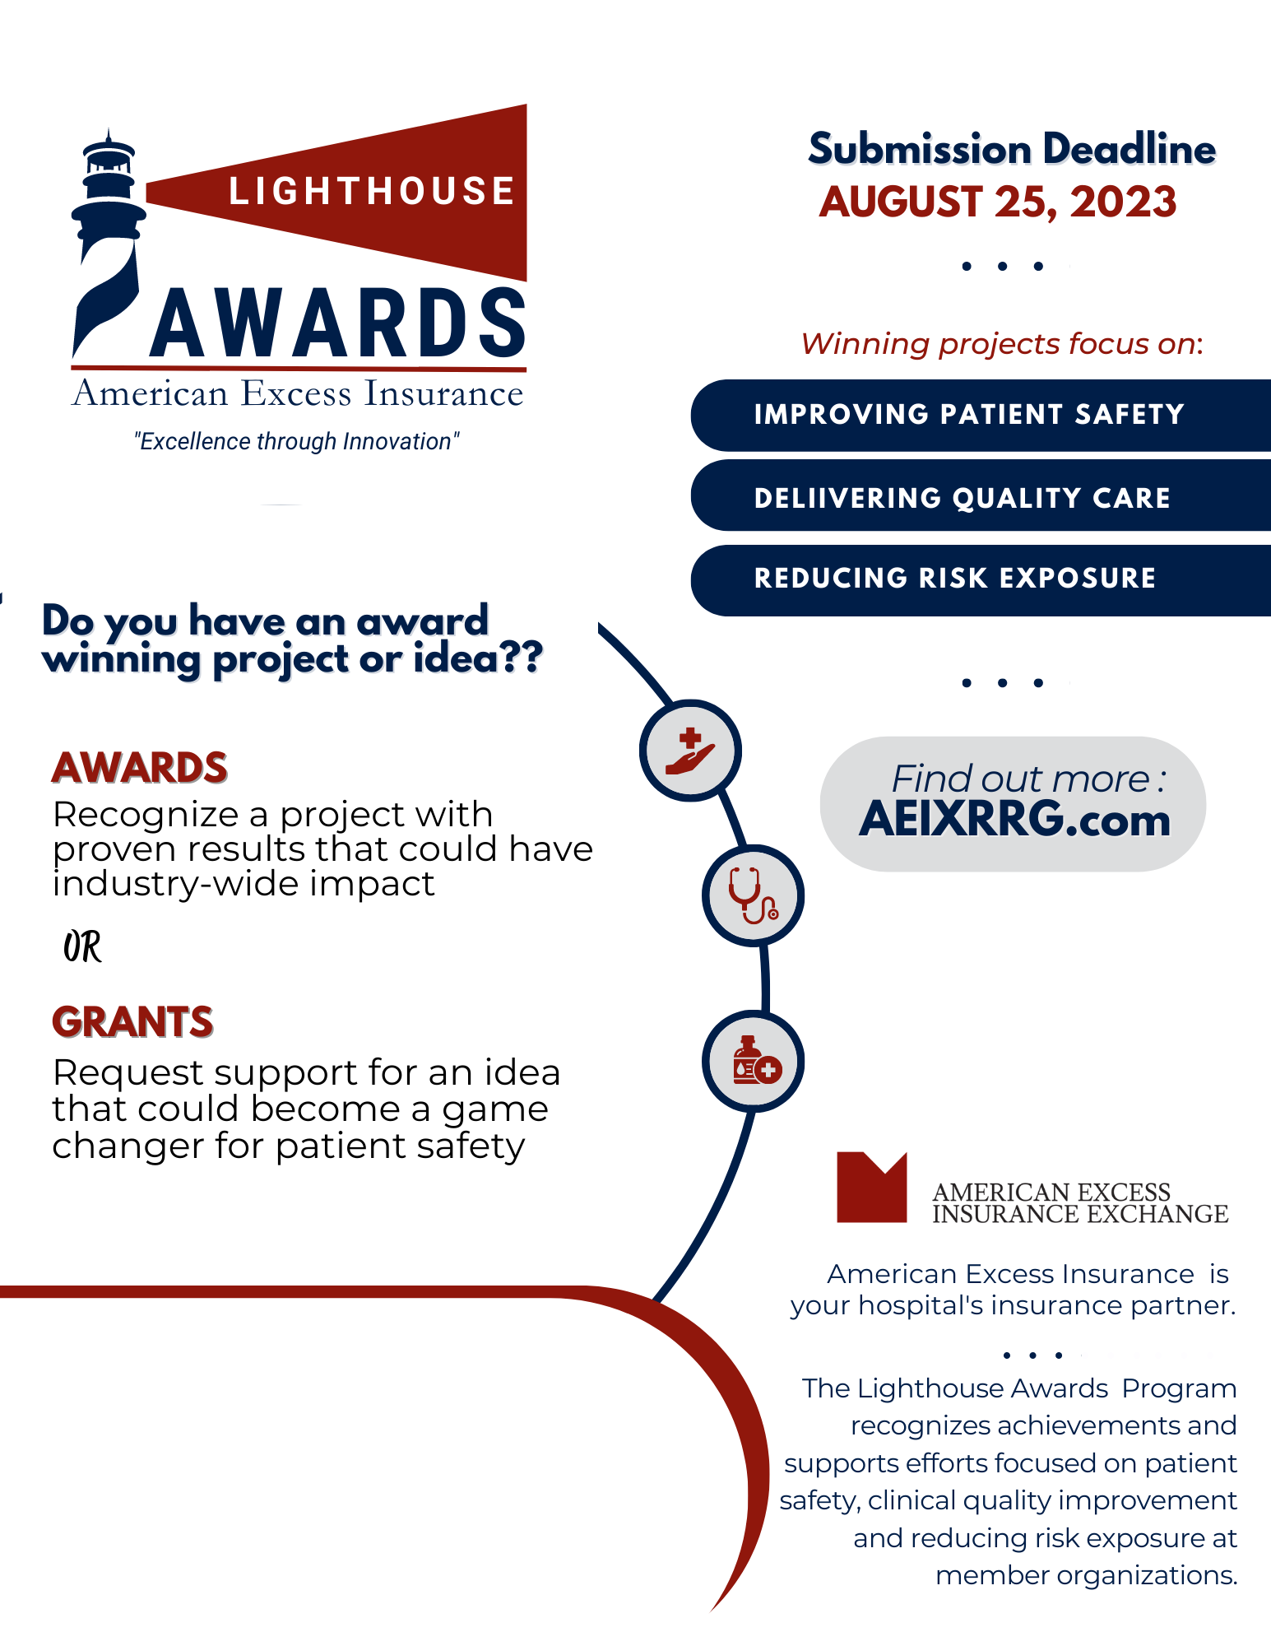
To get started with your idea contact:
Name / Title
Email Address / Phone Number
Deadline(s) Info

